**MIDDLE EAST TECHNICAL UNIVERSITY**

**ELECTRICAL AND ELECTRONICS ENGINEERING DEPARTMENT**



**EE463 STATIC POWER CONVERSION-I**

**PROJECT #2 REPORT**

**SIMULATION and DESIGN of the HARDWARE PROJECT**

**DESIGN of an INSULATED POWER SUPPLY**

**Due Date: 31.03.2019**

**Team Members:**

**Furkan TOKGÖZ 2031458**

**İven GÜZEL 2030831**

Table of Contents

**No table of contents entries found.**

# INTRODUCTION

In this project, designing an insulated power supply for the hardware project of EE464-Spring 2019 is aimed. As the hardware project our group has selected Forward Converter #4 whose design specifications are listed as such:

* **Minimum input voltage:** 24V
* **Maximum input voltage:** 48V
* **Output Voltage:** 10V
* **Output Power:** 40W
* **Output Volt. Peak-to-Peak Ripple:** 2%
* **Line Regulation:** 2%
* **Load Regulation:** 2%

To add a path for the demagnetizing current of the core, we decided to run two series of simulations which are on the practical forward converter with a tertiary winding as the demagnetizing winding and two-switch forward converter. After comparing the results, we decided to select our topology for the hardware project.

# DESIGN of an INSULATED POWER SUPPLY

## Part a: Steady State Operation of the Forward Converter

**Practical Forward Converter:**

Simulink model of this topology can be seen in Figure a.1.

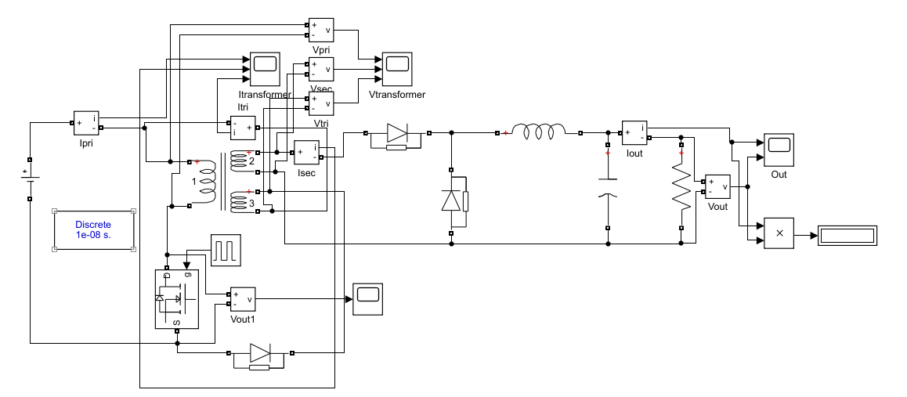

Figure a.1: Practical Forward Converter

**Two-Switch Forward Converter:**

## Part b: Design of the Transformer

## 

The first step of designing transformer is the calculation of “Area Product” for our design. Area product is a constant which is a product of the cross-section area and window area of the core. One can easily choose suitable core for the transformer with the help of area product. The required area product can be calculated as follows:

(1)

where P is output power of 40 W, J is the current density of 500 circ.mil/A, K is a constant of 0.0005 for forward converter, B is flux density of 1300 Gauss and f is frequency of 30 kHz. The result of this calculation is 1.05 cm4. So, we have checked the cores which is offered by the department and found core *0P43434EC* which has an area product of 1.21 cm4 as can be seen in Fig.X. So, This core was suitable for our design and we have decided to use it.

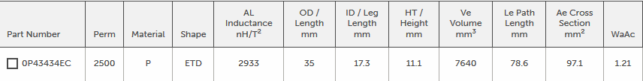

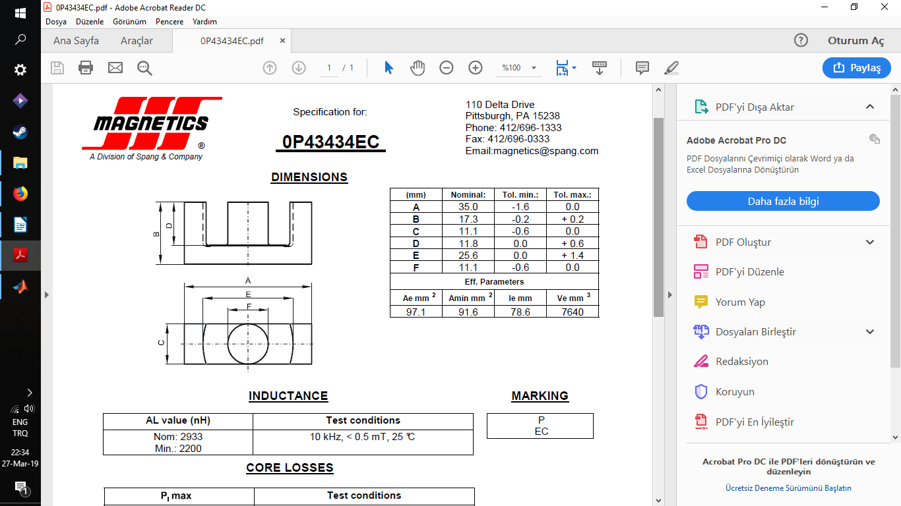 This core is made from P material and it is an E core with a cylindrical middle leg which can be seen in Fig.X.

Next thing to do was calculating number of turns on primary side of the transformer. For this purpose we have used the following formula.

(2)

where V is maximum voltage of primary side and Ae is the cross section area of the core. We have found required number of turns for primary side as 32. After that, we needed to find secondary number of turns of the transformer. As we all know, input voltage of the transformer changes between 24 to 48 V. Also, it is advised not to increase the duty cycle of the forward converter above 0.5. Because, there should be enough time for reset circuit to send remaining current to secondary side. So, the transformer should be able to transfer required power at minimum voltage and maximum duty cycle. If input voltage increases to a higher value, we can easily decrease duty cycle to transfer same amount of power. To calculate secondary side number of turns we have used following formula

(3)

We have added a margin voltage to output voltage because there might be a voltage drop because of diodes and inductor. Vpmin is 24 V and Dmax is 0.5 for this case. The resultant secondary side number of turns is 29. Finally, the reset winding number of turns is decided to be equal to primary number of turns which is 32.

Then we have decided the cable size for the transformer. 4 A/mm2 is commonly accepted in power electronics designs. So, we chose AWG 17 for primary side, AWG 15 for secondary side and AWG 25 for reset winding. To check the feasibility of windings we have calculated winding factor.

(4)

Winding factor of the transformer was in acceptable limits. So, we have moved on to DC loss calculation. For this purpose, we needed mean length per turn of the cables so that we can calculate total length of the windings. The following formula calculates mean length per turn for the selected core.

(5)

Essentially, we have calculated the circumference of a circle in this formula. E and F are the values which can be seen in Fig.X. Since, cable will be wound on middle leg of the core, they will pile up closer to the middle. So, there is a factor of 0.5 which takes that into account.

The total DC resistance of the cables is found as 39 mOhm. From I2*R formula, the copper loss of the transformer is found as 0.35 W.

The next thing to do was calculating core loss of the transformer. For this purpose we have used Steinmetz core loss equation which is given in the website of the Magnetics for P type materials.

(6)

T is the ambient temperature which is assumed to be 50 C and Ve is the volume of the core. The core loss of the transformer was found as 0.4 W.

Transformer design is an iterative process which needs recalculation. So, we have written a MATLAB script to ease the process. The purpose of the recalculations was to get a close core and copper loss results. Because it means we have fully utilized the transformer core.

## Part c: Simulation of the converter with ideal switches and transformer

## Part d: Border of DCM

The peak-peak ripple current on the inductor can be calculated for rising current during the ON-time:

So that, if the load current is bigger than ****, the converter gets into the DCM.

## Part e: More Realistic Transformer Simulation

## Part f: Efficiency of the Converter

## Part h: Preliminary Component Selection